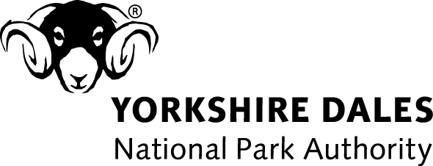
Right of Way Statement

Location

1. The above development would/would not* affect land crossed by/within 5 metres* of a public right of way *(please circle as appropriate)

2. If the land is crossed by/within 5 metres of a public right of way, please indicate its status (eg public footpath; public bridleway); give its reference number if known, and 2 places on either side of the land connected by it

3. If the development would affect land crossed by or within 5 metres of a public right of way what measures are proposed:

a) to protect the public during the course of any building works forming part of the development

…………………………………………………………………………………………

…………………………………………………………………………………………

b) retain their right of access in the long-term? (guidance may be sought from YDNPA Ranger Service)

…………………………………………………………………………………………

…………………………………………………………………………………………

Signed Agent/Applicant (please specify)

Date

